**Select All Data from Database**

select * from dbo.statewise_results;

select * from dbo.partywise_results;

select * from dbo.constituencywise_results;

select * from dbo.state;

select * from dbo.constituencywise_details;

Task 1) Total Seats

select distinct count(Parliament_Constituency)

from dbo.constituencywise_results;



Task 3) What is the total number of seats available for elections in each state

select s.state as State_Name,

count(cr.Parliament_constituency) as Parliament_Seats

from dbo.constituencywise_results cr

INNER JOIN statewise_results sr ON cr.Parliament_Constituency = sr.Parliament_Constituency

INNER JOIN dbo.state s ON sr.State_ID = s.State_ID

GROUP BY s.State ;

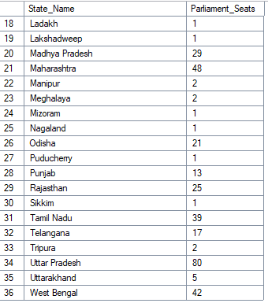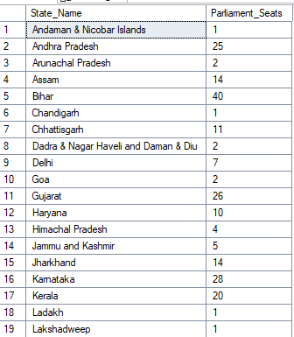

Task 4) Total Seats Won by NDA Allianz

SELECT

SUM(CASE

WHEN party IN (

'Bharatiya Janata Party - BJP',

'Telugu Desam - TDP',

'Janata Dal (United) - JD(U)',

'Shiv Sena - SHS',

'AJSU Party - AJSUP',

'Apna Dal (Soneylal) - ADAL',

'Asom Gana Parishad - AGP',

'Hindustani Awam Morcha (Secular) - HAMS',

'Janasena Party - JnP',

'Janata Dal (Secular) - JD(S)',

'Lok Janshakti Party(Ram Vilas) - LJPRV',

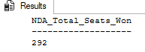 'Nationalist Congress Party - NCP',

'Rashtriya Lok Dal - RLD',

'Sikkim Krantikari Morcha - SKM'

) THEN [Won]

ELSE 0

END) AS NDA_Total_Seats_Won

FROM

dbo.partywise_results;

Task 5) Seats Won by NDA Allianz Parties

SELECT

party as Party_Name,

won as Seats_Won

FROM

dbo.partywise_results

WHERE

party IN (

'Bharatiya Janata Party - BJP',

'Telugu Desam - TDP',

'Janata Dal (United) - JD(U)',

'Shiv Sena - SHS',

'AJSU Party - AJSUP',

'Apna Dal (Soneylal) - ADAL',

'Asom Gana Parishad - AGP',

'Hindustani Awam Morcha (Secular) - HAMS',

'Janasena Party - JnP',

'Janata Dal (Secular) - JD(S)',

'Lok Janshakti Party(Ram Vilas) - LJPRV',

'Nationalist Congress Party - NCP',

'Rashtriya Lok Dal - RLD',

'Sikkim Krantikari Morcha - SKM'

)

ORDER BY Seats_Won DESC;

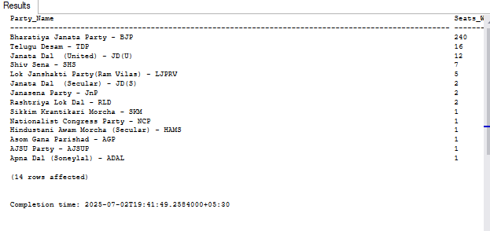

Task 6) Total Seats Won by I.N.D.I.A. Allianz

SELECT

SUM(CASE

WHEN party IN (

'Indian National Congress - INC',

'Aam Aadmi Party - AAAP',

'All India Trinamool Congress - AITC',

'Bharat Adivasi Party - BHRTADVSIP',

'Communist Party of India (Marxist) - CPI(M)',

'Communist Party of India (Marxist-Leninist) (Liberation) - CPI(ML)(L)',

'Communist Party of India - CPI',

'Dravida Munnetra Kazhagam - DMK',

'Indian Union Muslim League - IUML',

'Nat`Jammu & Kashmir National Conference - JKN',

'Jharkhand Mukti Morcha - JMM',

'Jammu & Kashmir National Conference - JKN',

'Kerala Congress - KEC',

'Marumalarchi Dravida Munnetra Kazhagam - MDMK',

'Nationalist Congress Party Sharadchandra Pawar - NCPSP',

'Rashtriya Janata Dal - RJD',

'Rashtriya Loktantrik Party - RLTP',

'Revolutionary Socialist Party - RSP',

'Samajwadi Party - SP',

'Shiv Sena (Uddhav Balasaheb Thackrey) - SHSUBT',

'Viduthalai Chiruthaigal Katchi - VCK'

) THEN [Won]

ELSE 0

END) AS INDIA_Total_Seats_Won

FROM

dbo.partywise_results;

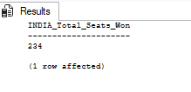

Task 7) Seats Won by I.N.D.I.A. Allianz Parties

SELECT

party as Party_Name,

won as Seats_Won

FROM

dbo.partywise_results

WHERE

party IN (

'Indian National Congress - INC',

'Aam Aadmi Party - AAAP',

'All India Trinamool Congress - AITC',

'Bharat Adivasi Party - BHRTADVSIP',

'Communist Party of India (Marxist) - CPI(M)',

'Communist Party of India (Marxist-Leninist) (Liberation) - CPI(ML)(L)',

'Communist Party of India - CPI',

'Dravida Munnetra Kazhagam - DMK',

'Indian Union Muslim League - IUML',

'Nat`Jammu & Kashmir National Conference - JKN',

'Jharkhand Mukti Morcha - JMM',

'Jammu & Kashmir National Conference - JKN',

'Kerala Congress - KEC',

'Marumalarchi Dravida Munnetra Kazhagam - MDMK',

'Nationalist Congress Party Sharadchandra Pawar - NCPSP',

'Rashtriya Janata Dal - RJD',

'Rashtriya Loktantrik Party - RLTP',

'Revolutionary Socialist Party - RSP',

'Samajwadi Party - SP',

'Shiv Sena (Uddhav Balasaheb Thackrey) - SHSUBT',

'Viduthalai Chiruthaigal Katchi - VCK'

)

ORDER BY Seats_Won DESC;

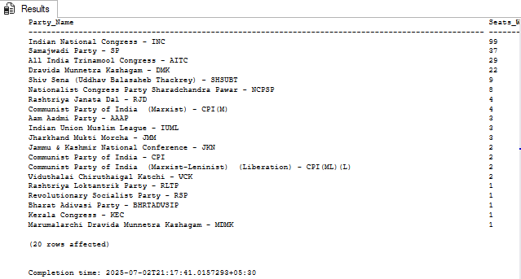

Task 8) Add new column field in table party wise results to get the Party Allianz as NDA, I.N.D.I.A and OTHER

ADD new Column

alter table dbo.partywise_results

Add Party_Alliance varchar(50);

--I.N.D.I.A Allianz

UPDATE dbo.partywise_results

SET party_alliance = 'I.N.D.I.A'

WHERE party IN (

'Indian National Congress - INC',

'Aam Aadmi Party - AAAP',

'All India Trinamool Congress - AITC',

'Bharat Adivasi Party - BHRTADVSIP',

'Communist Party of India (Marxist) - CPI(M)',

'Communist Party of India (Marxist-Leninist) (Liberation) - CPI(ML)(L)',

'Communist Party of India - CPI',

'Dravida Munnetra Kazhagam - DMK',

'Indian Union Muslim League - IUML',

'Jammu & Kashmir National Conference - JKN',

'Jharkhand Mukti Morcha - JMM',

'Kerala Congress - KEC',

'Marumalarchi Dravida Munnetra Kazhagam - MDMK',

'Nationalist Congress Party Sharadchandra Pawar - NCPSP',

'Rashtriya Janata Dal - RJD',

'Rashtriya Loktantrik Party - RLTP',

'Revolutionary Socialist Party - RSP',

'Samajwadi Party - SP',

'Shiv Sena (Uddhav Balasaheb Thackrey) - SHSUBT',

'Viduthalai Chiruthaigal Katchi - VCK'

);

--NDA Allianz

UPDATE dbo.partywise_results

SET party_alliance = 'NDA'

WHERE party IN (

'Bharatiya Janata Party - BJP',

'Telugu Desam - TDP',

'Janata Dal (United) - JD(U)',

'Shiv Sena - SHS',

'AJSU Party - AJSUP',

'Apna Dal (Soneylal) - ADAL',

'Asom Gana Parishad - AGP',

'Hindustani Awam Morcha (Secular) - HAMS',

'Janasena Party - JnP',

'Janata Dal (Secular) - JD(S)',

'Lok Janshakti Party(Ram Vilas) - LJPRV',

'Nationalist Congress Party - NCP',

'Rashtriya Lok Dal - RLD',

'Sikkim Krantikari Morcha - SKM'

);

--OTHER

UPDATE dbo.partywise_results

SET party_alliance = 'NON_Allianz'

WHERE party_alliance IS NULL;

Task 9) Which party alliance (NDA, I.N.D.I.A, or OTHER) won the most seats across all states?

select Party_Alliance , Sum(Won) As Number_of_Seats

from dbo.partywise_results

group by Party_Alliance ;

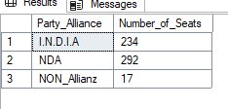

Task 10) Winning candidate's name, their party name, total votes, and the margin of victory for a specific state and constituency?

SELECT cr.Winning_Candidate,

p.Party,

p.party_alliance,

cr.Total_Votes,

cr.Margin,

cr.Constituency_Name,

s.State

FROM dbo.constituencywise_results cr

JOIN dbo.partywise_results p ON cr.Party_ID = p.Party_ID

JOIN dbo.statewise_results sr ON cr.Parliament_Constituency = sr.Parliament_Constituency

JOIN dbo.state s ON sr.State_ID = s.State_ID

WHERE s.State = 'Maharashtra' AND cr.Constituency_Name = 'AHMEDNAGAR';

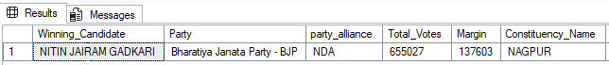

Task 11) What is the distribution of EVM votes versus postal votes for candidates in a specific constituency?

SELECT

cd.Candidate,

cd.Party,

cd.EVMVotes,

cd.PostalVotes,

cd.TotalVotes

FROM

dbo.constituencywise_details cd

JOIN

dbo.constituencywise_results cr ON cd.ConstituencyID = cr.Constituency_ID

WHERE

cr.Constituency_Name = 'MATHURA'

ORDER BY cd.TotalVotes DESC;

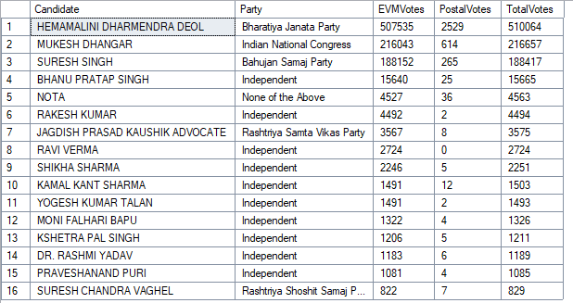

Task 12) Which parties won the most seats in s State, and how many seats did each party win?

SELECT

p.Party,

COUNT(cr.Constituency_ID) AS Seats_Won

FROM

dbo.constituencywise_results cr

JOIN

dbo.partywise_results p ON cr.Party_ID = p.Party_ID

JOIN

dbo.statewise_results sr ON cr.Parliament_Constituency = sr.Parliament_Constituency

JOIN dbo.state s ON sr.State_ID = s.State_ID

WHERE

s.state = 'Andhra Pradesh'

GROUP BY

p.Party

ORDER BY

Seats_Won DESC;

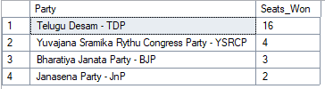

Task 13)Which candidate received the highest number of EVM votes in each constituency (Top 10)?

with SN as (

select s.State,

cr1.Constituency_ID

FROM

dbo.constituencywise_results cr1

JOIN

dbo.statewise_results sr ON

cr1.Parliament_Constituency = sr.Parliament_Constituency

JOIN dbo.state s ON sr.State_ID = s.State_ID

)

select top 10

cr.Constituency_Name,

cd.Candidate,

SN.State,

cd.Party,

cd.EVMVotes,

cr.Total_Votes

from dbo.constituencywise_details cd

inner join dbo.constituencywise_results cr

ON cd.ConstituencyID = cr.Constituency_ID

inner join SN on cd.ConstituencyID = SN.Constituency_ID

order by cd.EVMVotes DESC;

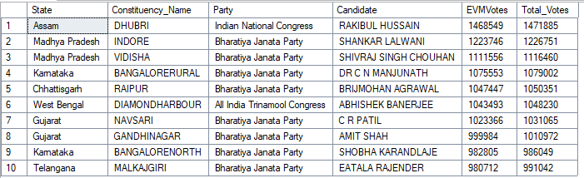

Task 14) For the state of Maharashtra, what are the total number of seats, total number of candidates, total number of parties, total votes (including EVM and postal), and the breakdown of EVM and postal votes?

SELECT

COUNT(DISTINCT cr.Constituency_ID) AS Total_Seats,

COUNT(DISTINCT cd.Candidate) AS Total_Candidates,

COUNT(DISTINCT p.Party) AS Total_Parties,

SUM(cd.EVMVotes + cd.PostalVotes) AS Total_Votes,

SUM(cd.EVMVotes) AS Total_EVM_Votes,

SUM(cd.PostalVotes) AS Total_Postal_Votes

FROM

constituencywise_results cr

JOIN

constituencywise_details cd ON cr.Constituency_ID = cd.ConstituencyID

JOIN

statewise_results sr ON cr.Parliament_Constituency = sr.Parliament_Constituency

JOIN

state s ON sr.State_ID = s.State_ID

JOIN

partywise_results p ON cr.Party_ID = p.Party_ID

WHERE

s.State = 'Tamil Nadu';

Overall No. of Parties, No. of candidate participated,

Total number of Votes cast including EVM And Postal Votes in Parliament Election 2024

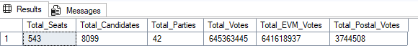

Specific State – Tamil Nadu

No. of Parties, No. of candidate participated,

Total number of Votes cast including EVM And Postal Votes in Parliament Election 2024

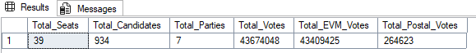

Task 15) Which candidate won and which candidate was the runner-up in each constituency of State for the 2024 elections?

WITH RankedCandidates AS (

SELECT

cd.ConstituencyID,

cd.Candidate,

cd.Party,

cd.EVMVotes,

cd.PostalVotes,

cd.EVMVotes + cd.PostalVotes AS Total_Votes,

ROW_NUMBER()

OVER (PARTITION BY cd.ConstituencyID

ORDER BY cd.EVMVotes + cd.PostalVotes

DESC) AS VoteRank

FROM

dbo.constituencywise_details cd

JOIN

dbo.constituencywise_results cr

ON cd.ConstituencyID = cr.Constituency_ID

JOIN

dbo.statewise_results sr

ON cr.Parliament_Constituency = sr.Parliament_Constituency

JOIN

dbo.state s ON sr.State_ID = s.State_ID

WHERE

s.State = 'Maharashtra'

)

SELECT

cr.Constituency_Name,

MAX(CASE WHEN rc.VoteRank = 1 THEN rc.Candidate END) AS Winning_Candidate,

MAX(CASE WHEN rc.VoteRank = 2 THEN rc.Candidate END) AS Runnerup_Candidate

FROM

RankedCandidates rc

JOIN

dbo.constituencywise_results cr ON rc.ConstituencyID = cr.Constituency_ID

GROUP BY

cr.Constituency_Name

ORDER BY

cr.Constituency_Name;

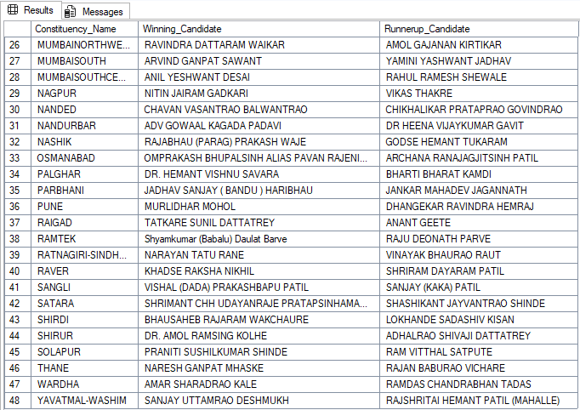

Task 16) Find Out Top 5 State: - Maximum no of candidate for Election

SELECT TOP 5

s.State,

COUNT(cd.Candidate) AS Total_Candidates_for_Election

FROM

constituencywise_results cr

JOIN

constituencywise_details cd ON cr.Constituency_ID = cd.ConstituencyID

JOIN

statewise_results sr ON cr.Parliament_Constituency = sr.Parliament_Constituency

JOIN

state s ON sr.State_ID = s.State_ID

JOIN

partywise_results p ON cr.Party_ID = p.Party_ID

group by s.State

order by Total_Candidates_for_Election DESC;

